Dashboard Accuknox

* Open/Click this link to open the application’s repository “ <https://github.com/kams11/Dashboard_React> “.
* Click on Code > Download ZIP as shown in Image

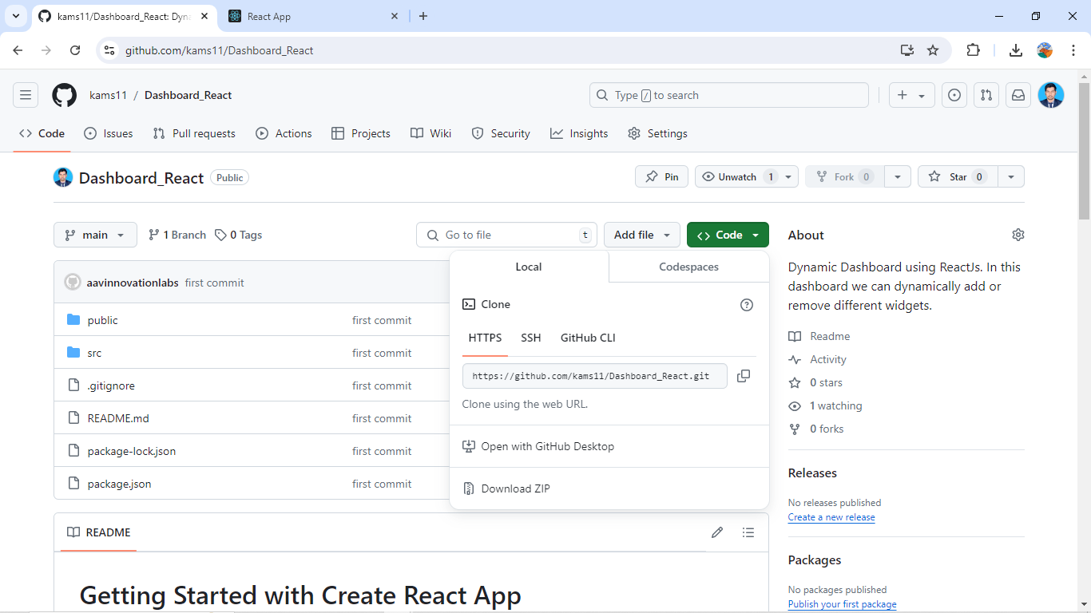

* Open the location of downloaded ZIP file. Right click on the file And click on Extract To Dashboard_React-main

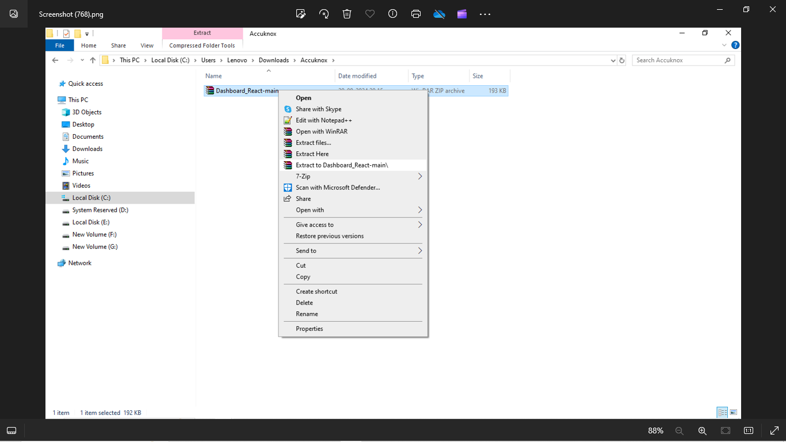

* Open VS Code, click on Open Folder. Select the folder “Dashboard_React-main”.

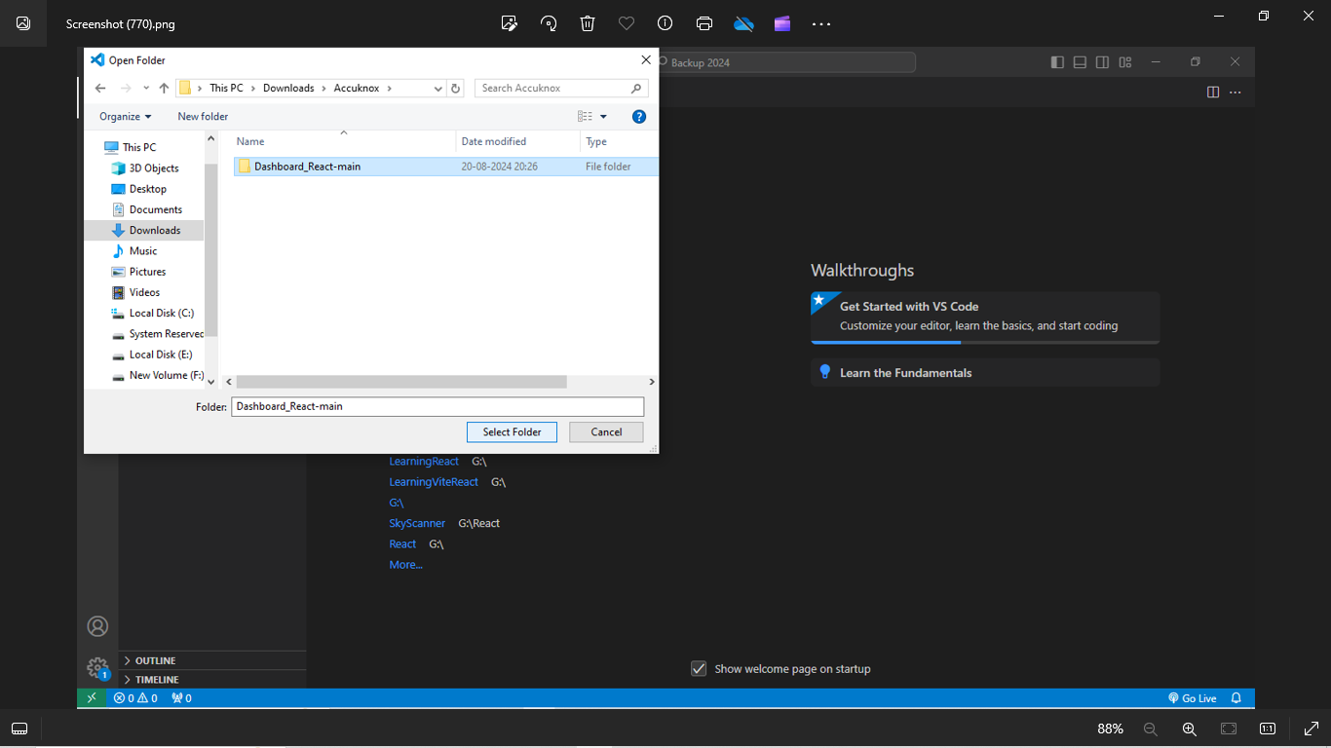

* Open Terminal as shown in image.

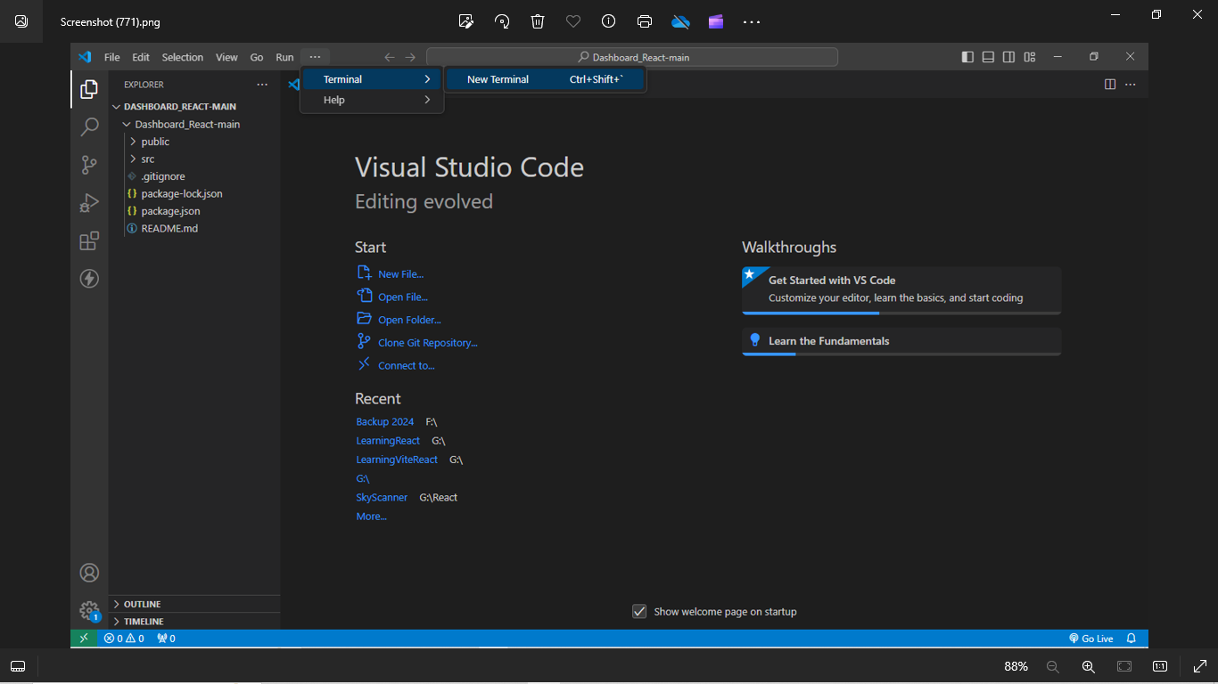

* In the terminal, provide the project_name i.e. cd Dashboard_React-main And click ENTER.

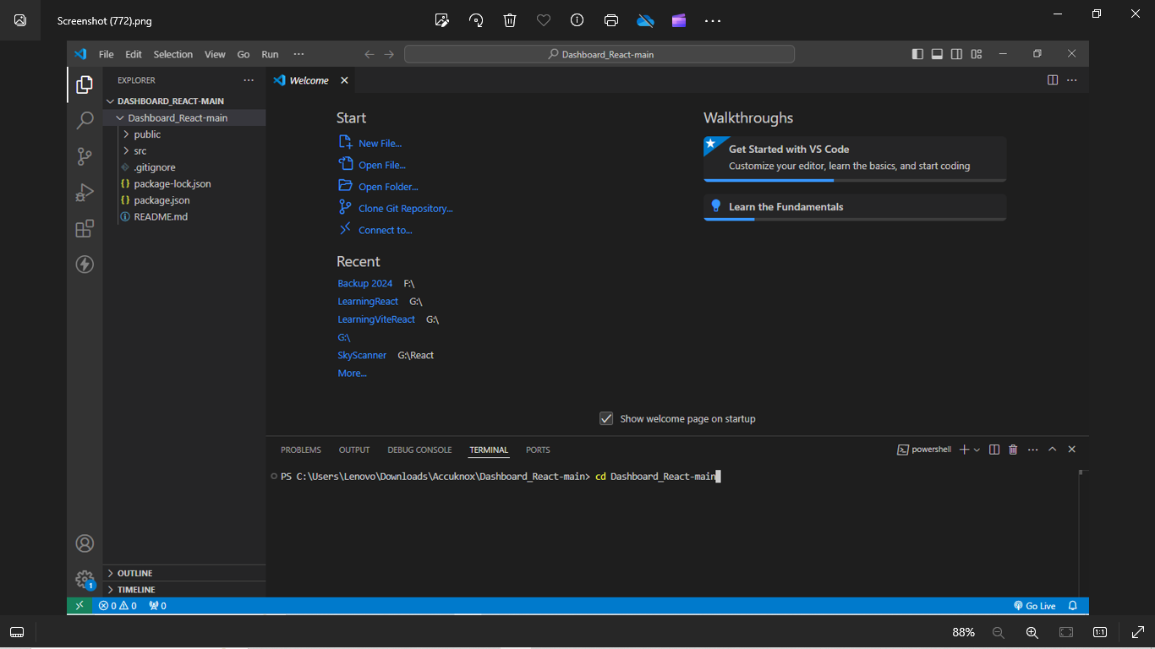

* Then type npm i in the terminal as next command. It will create a folder ‘node_modules’ in the project.

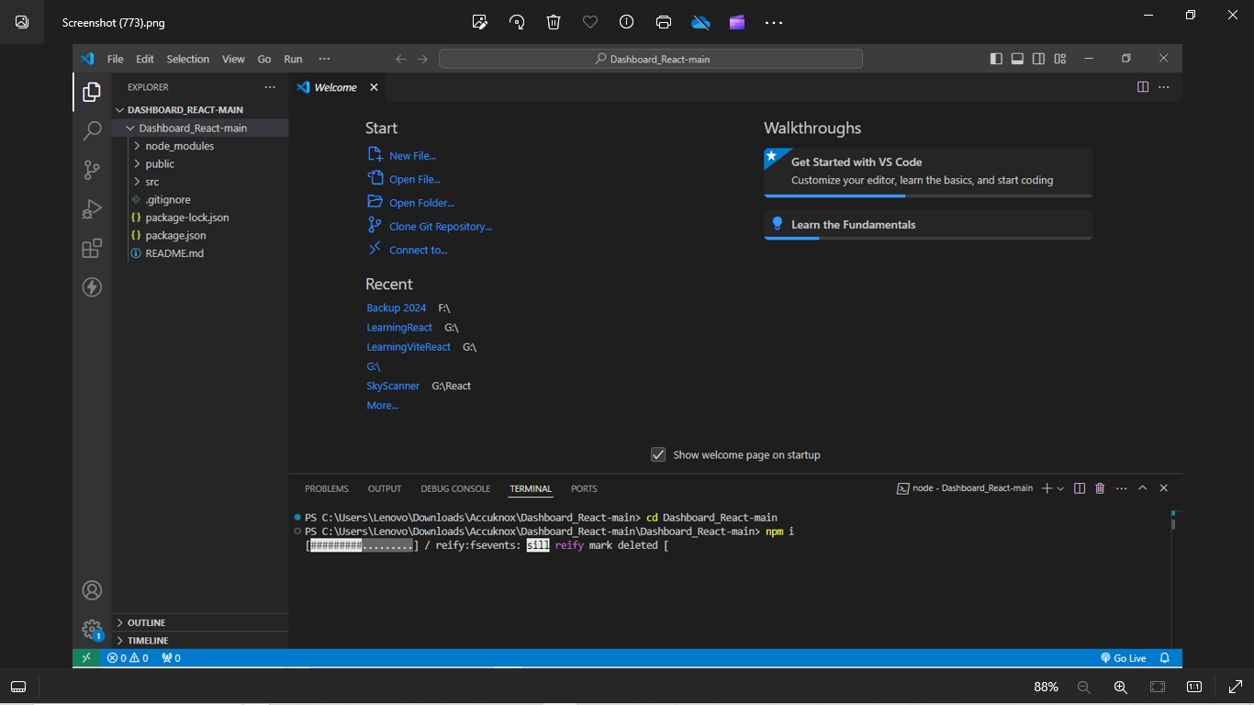

* Type npm start in the terminal to run the application.

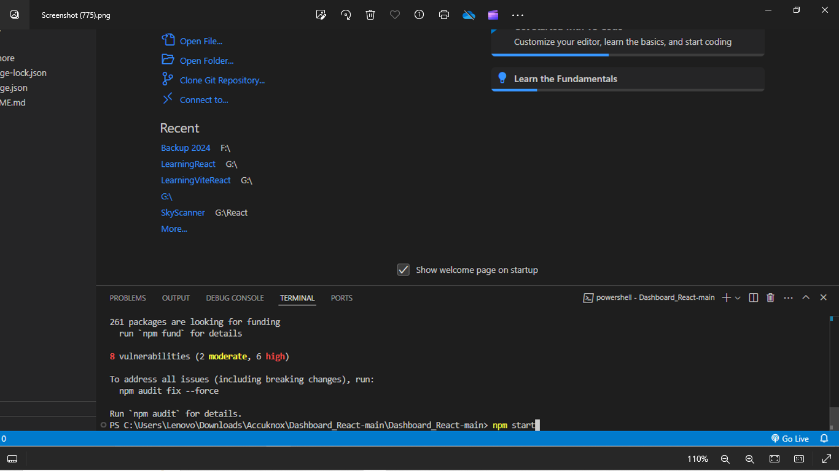

It will open a tab in your default browser having the url <http://localhost:3000/>

Note: If the tab if not opening directly, you can type the url and open the app.

In the Homepage, a Banner picture of ‘CNAPP” is added. Click on that to redirect to Dashboard.